Mandalos. Spalvinimas, reikšmė ir naudingumas

[](http://www.vmnn.lt/wp-content/uploads/2016/09/mandalos2-1.jpg)[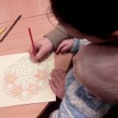](http://www.vmnn.lt/wp-content/uploads/2016/09/mandalos3-1.jpg)[](http://www.vmnn.lt/wp-content/uploads/2016/09/mandalos4-1.jpg)[](http://www.vmnn.lt/wp-content/uploads/2016/09/mandalos5-1.jpg)